
Kansas Educational Leadership Institute Enrollment/Contact/Intent Form 2025-2026
Superintendent/Assistant Superintendent/Special Education Director/Assistant Director KELI@ksu.edu, 785-532-5758, 363 Bluemont Hall, 1114 Mid-Campus Dr N, Manhattan KS 66506
PLEASE COMPLETE ALL SECTIONS:
First Name
Last Name
USD Number & Name
Select your title  ↓ | KELI | Year 1  ↓ | OR | KELI  ↓ | Year 2
Superintendent | Year 1 |  |  | Year 2
Asst Superintendent* | Year 1 |  |  | Year 2
Spec Ed Director | Year 1 |  |  | Year 2
Asst Spec Ed Director | Year 1 |  |  | Year 2
If *Assistant Superintendent, circle/indicate any additional duties from list below: Curriculum & Assessment Dir of Elementary Ed
Professional Learning Dir of Secondary Ed
Finance Student Support Service (At-risk ELL Migrant)
Operations (Food Service & Transport) Other (specify)
District Address:
Street
City Zip
Email
Telephone
For Asst Supt or Asst Director: Please provide your Superintendent/Director’s: Name: Email address:
What District license do you hold currently?

Initial or Professional or License Pending
District Level Enrollment fee: Year One = $2,500 Year Two = $1,250
Scan and email the following items to: keli@ksu.edu

- Completed and signed form
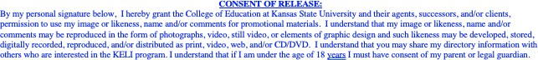
- Your picture for KELI files/recognition
Signature: |  |  | Date:

